1.10.1.19 Browse retail price lists
When there are all prices lists maintained on your side (in NL domain) on customers´ levels, you can check the prices for your NL customers in this function.
Basically you see here all the prices for our collection, slitted and extruded edges (ABS, melamines, veneers, glues and cleaners).
If the price is maintained here, it is automatically added when entering sales order.

Customer: Sold to party number
Item Number: full article number
+ Next
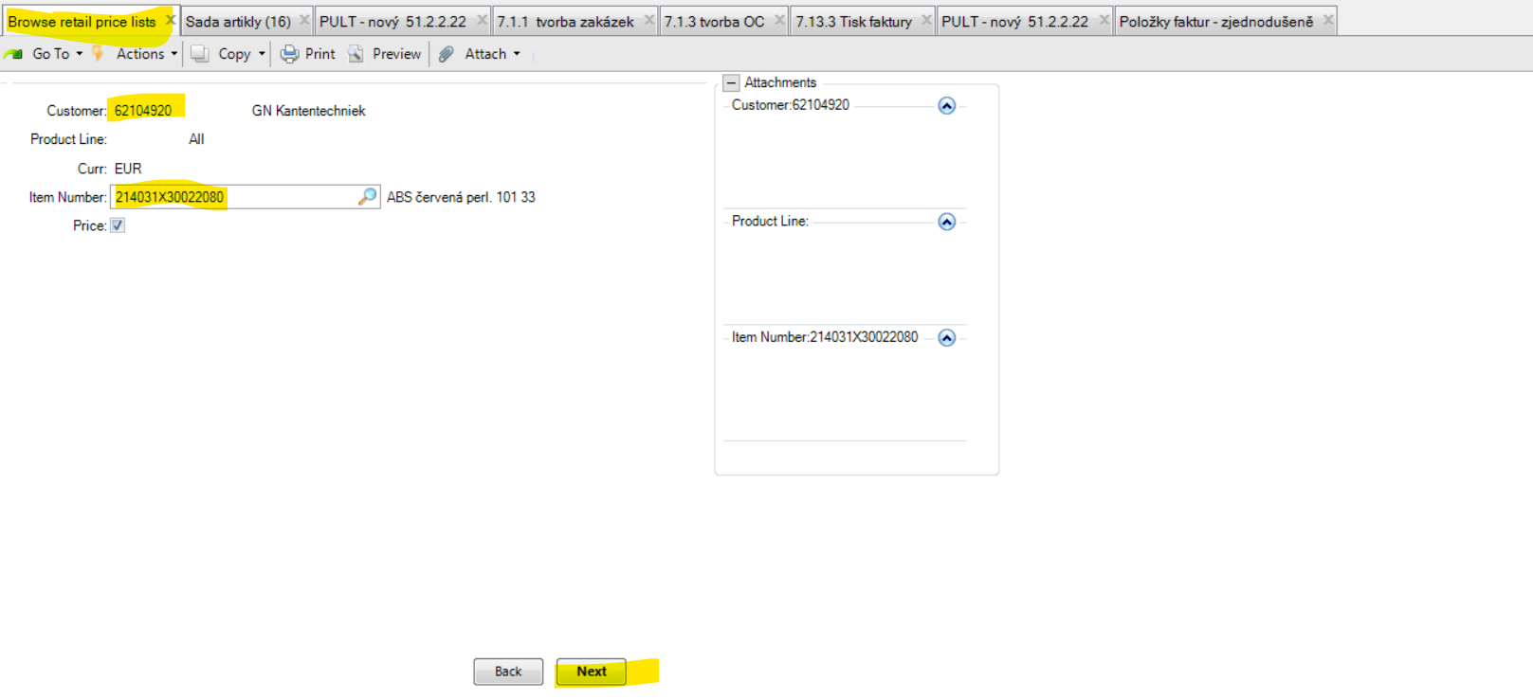
Below you can see the price in EUR for the article from Product Group PG 1010 (ABS UNI collection).
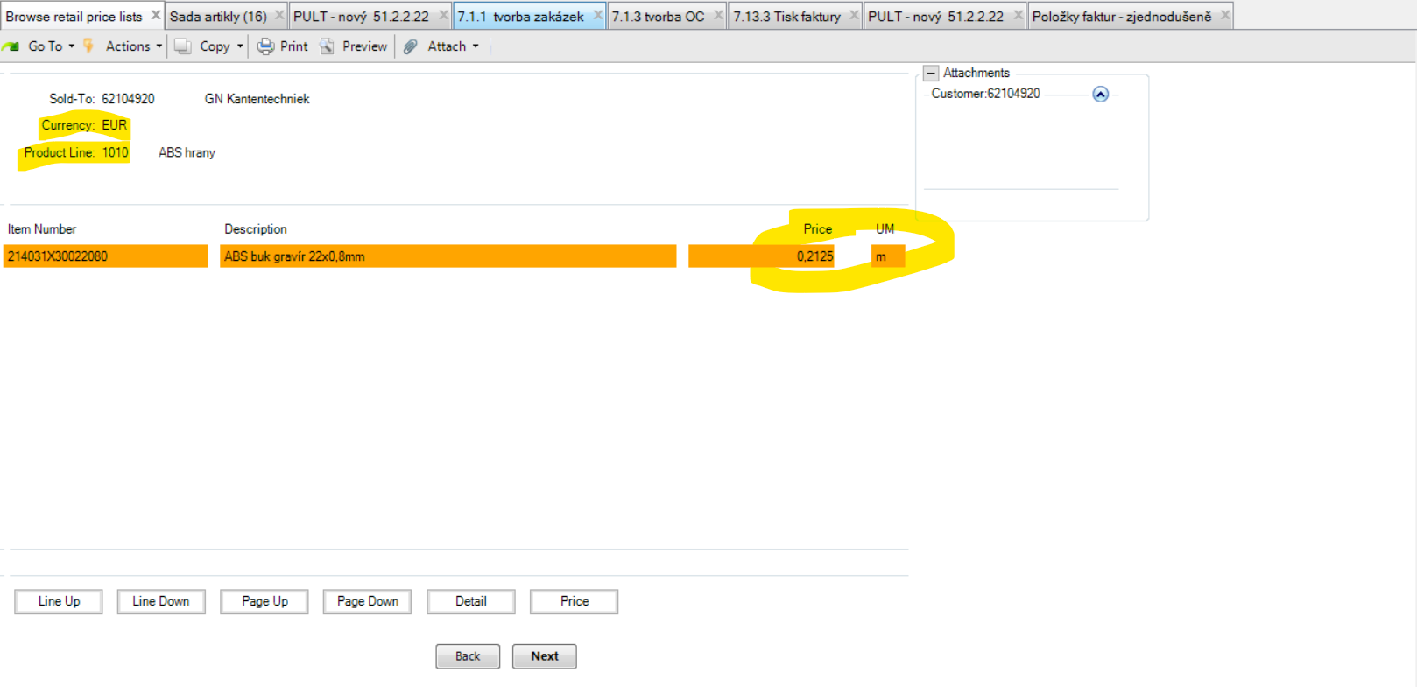

If you want to see the deatil about the price, go via Detail.
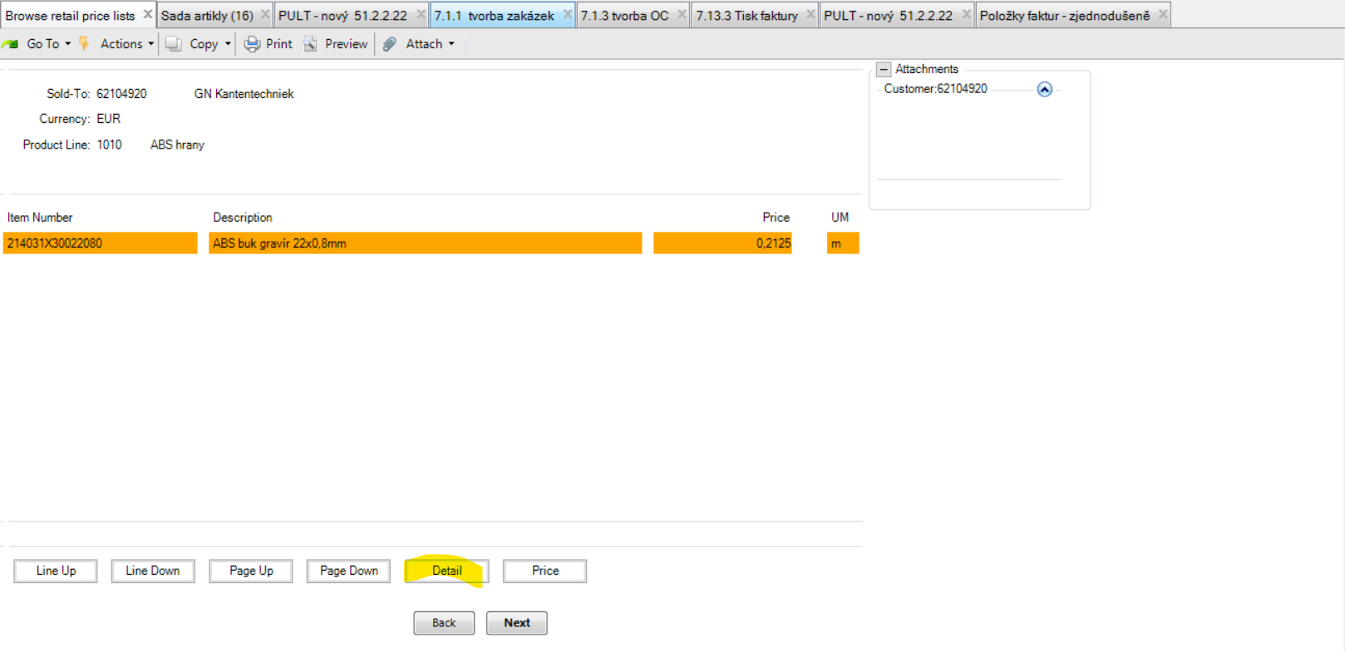

+ Next
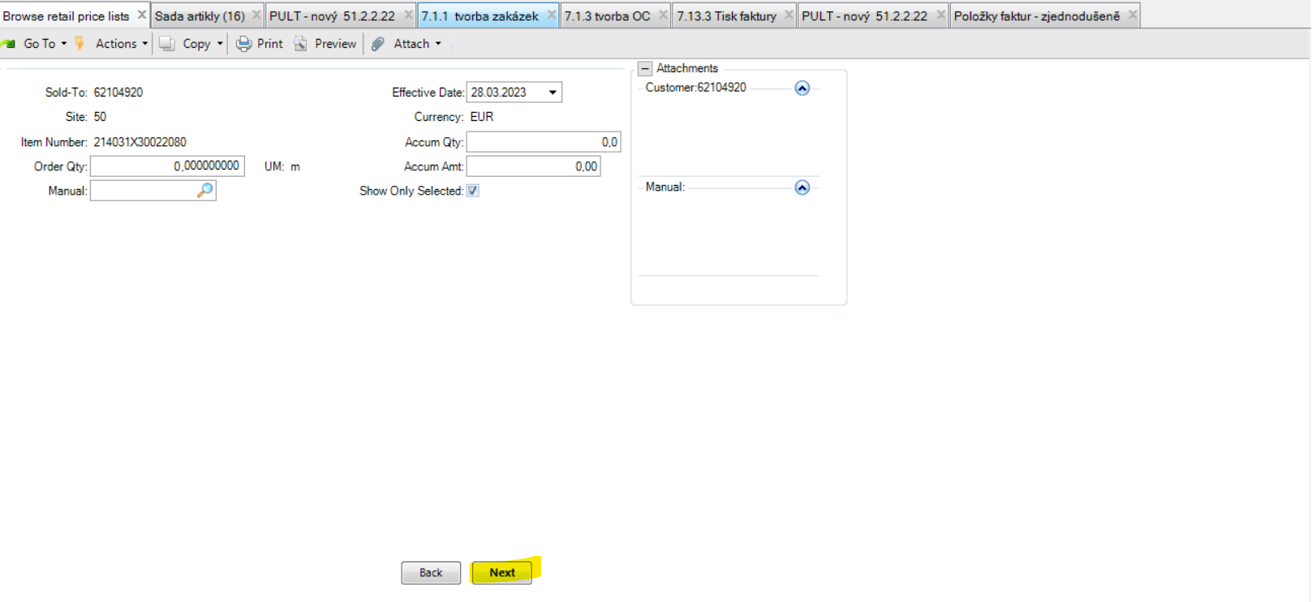

You can see here what Item Category has this product and what price list Cat was set for this client.
We can see here that GN Kantentechniek has F price list for ABS UNI.

+ Back (you can back from this function)
